Ranger Road Programs – Support for Veterans
Ranger Road is a nonprofit charity providing veterans the necessary tools to be successful from the crucial transition from military to civilian life.
Programs:
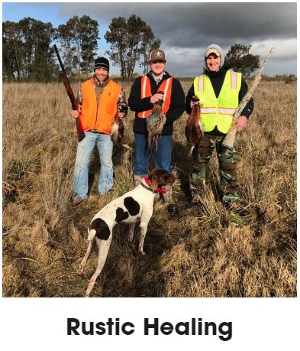
Rustic Healing – this program is designed to get Veterans back out in nature. Events take place in locations all over America. Rustic Healing put together hunting trips for deer, pigs, mountain lions, antelope and more. If you are interested in outdoor fun, please sign up here.


Ranger Road Motors is an adaptive motor sports group that puts Veterans and first responders of all abilities on, in or around motor vehicles to compete or just have fun. Enjoy growing a race family that supports each member on and off the track. To join, please sign up here.

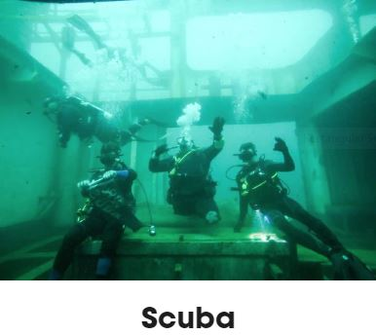
Scuba is a program designed to get the veteran(s) back in the water. This course is open to all Veterans with or without disabilities. Sign up here.

Sailing is a program where Veterans can go for leisurely cruises or learn competitive sailing under the training of Ron Young. Sailing takes place in and around the SF Bay area.
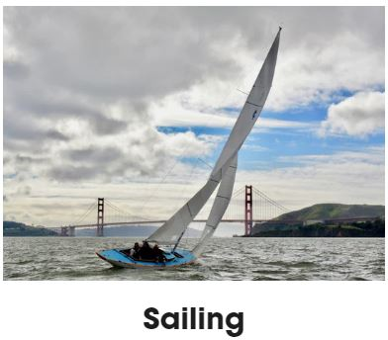

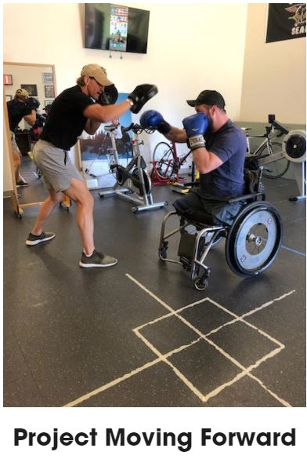
Project Moving Forward supports veterans with and without disabilities integrate with civilians to focus on community involvement, physical and emotional wellness.

The Shadow Arts Program works with high-risk veterans and pushes them to reincarnate the warrior within. This program provides a gym membership to Veterans at a local MMA gym and utilize a buddy system for additional support.
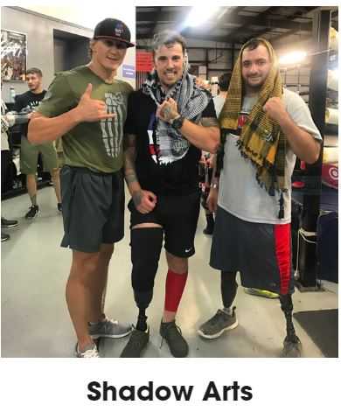

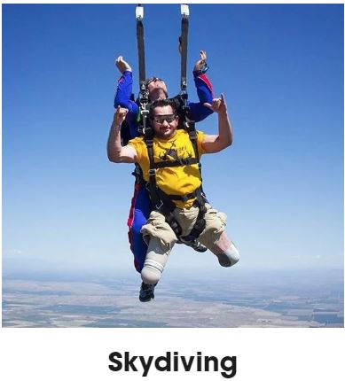

Skydiving! Sign up here.

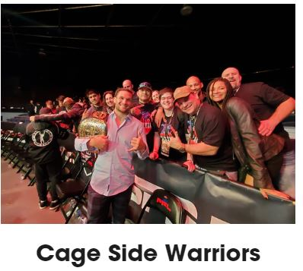
Cage Side Warriors works closely with MMA organizations. Ranger Road takes a select group of veterans and their loved ones to various events all over America. Sign up here.


Gibborim Rifle Project’s goal is to support the veteran community with true grit. Ranger Road Gibborim Rifle Project put rifles in the hands of worries who deserve it. Build a rifle for a deserving veteran and then assist him/her with putting some meat in his/her freezer with the help of another Ranger Road Program, Rustic Healing.

Doc’s Corner functions to help anybody who needs it in finding mental health resources in their areas, wherever they may live across the United States.
